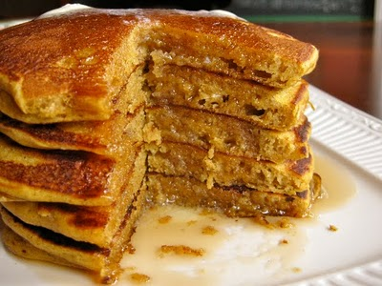
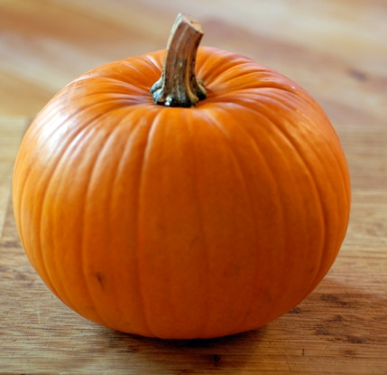
Pumpkin Pancakes
1 ½ cup Milk 2 teaspoons baking powder
1 cup pumpkin puree 1 teaspoon baking soda
1 egg 1 teaspoon ground allspice
2 Tablespoons vegetable oil 1 teaspoon ground cinnamon
2 Tablespoons vinegar ½ teaspoon ground ginger
2 cups Flour ½ teaspoon salt
3 Tablespoons Brown Sugar

Directions
- In a bowl, mix together the milk, pumpkin, egg, oil and vinegar. Combine the flour, brown sugar, baking powder, baking soda, allspice, cinnamon, ginger and salt in a separate bowl. Stir into the pumpkin mixture just enough to combine.
- Heat a lightly oiled griddle or frying pan over medium high heat. Pour or scoop the batter onto the griddle, using approximately 1/4 cup for each pancake. Brown on both sides and serve hot.

